Government Budget and National Saving
- The government budget balance equals
  - Government spending – taxes + government transfers
  - Taxes – government spending + government transfers
  - Taxes – government spending – government transfers
  - Taxes + government spending + government transfers
  - Government transfers – government spending – taxes

- An expansionary fiscal policy enacted by the United States government
  - always includes a change in taxes.
  - moves the federal budget toward deficit.
  - moves the federal budget toward surplus.
  - moves the federal bud\get toward balance.
  - only affects government spending.

- Country X has a budget deficit. Which of the following changes in government budget outlays and tax revenues will result in a decrease in Country X’s government budget deficit?
Gov Outlays/Expenditure Tax Revenues
- Fall by 100 Fall by 600
- Fall by 200 Fall by 200
- Rise by 300 Fall by 300
- Rise by 400 Rise by 600
- Rise by 500 Rise by 500

- Suppose that in 2017 government outlays exceeded tax revenues. An increase in government purchases in 2018, with no other budgetary changes, would lead to which of the following from 2017 to 2018 ?
- An increase in the government budget surplus
- A decrease in the government budget surplus
- An increase in the government budget deficit
- A decrease in the government budget deficit
- A decrease in the national debt

- Deficit spending by the United States government is primarily financed by
  - decreasing the discount rate
  - increasing the money supply
  - depreciating the value of the dollar
  - increasing taxes
  - issuing new bonds (which effectively means they borrow money)

- Which of the following is an accumulation over a long period of time, and which applies to just one year.
National savings ________________________
Budget surplus_________________________
Budget deficit _________________________
National debt ___________________________

- What is the difference between national savings and national debt?

- If the government currently has savings (national savings) of 120 million dollars, but has expenditure that exceeds tax by 20 million in the current year, what is the value of:
National Savings Budget
- 140 million surplus
- 140 million deficit
- 120 million balanced
- 100 million deficit
- 100 million surplus

- Assume that the loanable funds market in Country X is currently in equilibrium.
- Draw a correctly labeled graph of the loanable funds market for Country X, and label the equilibrium interest rate as r* and the quantity of funds as QF*.
- Assume that the government of Country X, which had a balanced budget, now increases its spending while holding taxes constant. Assume that the government funds the increase in spending with increased borrowing.
- What will be the impact of this policy action on the government’s budget balance?
- On your graph in part (a), show the impact of this policy action on the interest rate and quantity of funds.
- Given your answer in part (b) (ii), how will private-sector interest-sensitive expenditures be affected?
- Given your answer in part (c), what will be the impact on the long-run growth rate of the economy? Explain.
1 | C | 6 | Accumulation  One year  One year  Accumulation
2 | B | 7 | National savings is a positive number. National debt is a negative number.
3 | D | 8 | D
4 | C | 9
5 | E | 10

Answer

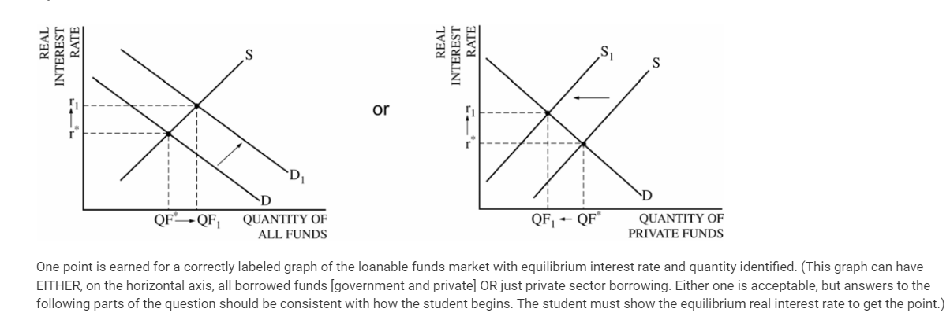
b
Budget deficit
Rightward shift of the demand curve OR leftward shift of supply curve → higher interest rate
c Higher interest rate will reduce consumption and private investment spending
d growth rate will decrease or economy will grow at a reduced rate
less capital formation which would lead to economic growth (increase in the factors of production)

